**Report on Identifying Areas for High Yield Seeding Using Deep CNN and Depth Perception of RGBD Images from UAVs**

Chris Anderson*, Kevin Hu*

Institute for Aerospace Studies

University of Toronto, Canada

**Abstract**

This report introduces an innovative reforestation strategy utilizing Unmanned Aerial Vehicles (UAVs) and a ResNet-inspired U-Net CNN for automated seeding and precise image segmentation. **While achieving promising results in multi-class segmentation, challenges persist in accurately identifying high-yield areas, particularly in the Rangeland class during binary segmentation.** The study goes beyond conventional approaches by introducing scale invariance and modifying loss functions to address class imbalance. The report concludes with a forward-looking perspective, outlining proposed future work to refine the model and contribute to the evolution of reforestation strategies. The project stands at the forefront of advancements, combining UAV technology and deep learning to address urgent environmental concerns.

**Introduction**

Our research addresses the critical issue of identifying areas with a high likelihood of successful seeding amidst escalating rates of deforestation, driven by climate change and industrial activities. Traditional reforestation methods prove inadequate in mitigating the ecological consequences of habitat loss and carbon sequestration. To address this, we advocate for innovative strategies, particularly the use of Unmanned Aerial Vehicles (UAVs), which offer unprecedented opportunities for mass and automated seeding, marking a paradigm shift in conventional approaches.

Conventional methods, characterized by widespread seed distribution and hopeful anticipation of favorable outcomes, necessitate a more refined and efficient approach. Our research introduces a transformative paradigm by employing UAVs for targeted seeding, integrating data analysis and machine learning methodologies.

A key component of our approach involves deploying a deep Convolutional Neural Network (CNN) in collaboration with depth perception derived from RGBD images captured by UAVs. This sophisticated integration aims to enhance the precision and efficiency of reforestation efforts by categorizing planting areas based on variables such as humidity, urbanization, and UAV image height. This meticulous approach reflects our commitment to leveraging machine learning techniques for informed decision-making in reforestation.

**Related Work**

Building on existing studies exploring the use of UAVs in reforestation [1][2], our endeavor seeks to extend the capabilities of such technologies. Previous research has established the viability of UAVs in automated seeding, showcasing their potential for large-scale reforestation efforts. These studies have primarily focused on the technical aspects of UAV deployment, including navigation, payload capacity, and seed dispersal mechanisms.

However, our project introduces a novel dimension by delving into data-driven methodologies for identifying high-yield seeding areas. While existing works acknowledge the potential of UAVs in reforestation, the emphasis has often been on the logistical challenges and the development of robust UAV systems. The integration of a deep Convolutional Neural Network (CNN) with depth perception from RGBD images represents a unique contribution, allowing for more precise and informed decision-making in the identification of optimal planting locations.

Moreover, this work extends beyond the conventional scope by addressing challenges associated with binary segmentation, particularly in the Rangeland class. Existing studies may not have explicitly tackled the nuances of accurately delineating high-yield areas in diverse environmental conditions. Our focus on scale invariance and modifications to loss functions to address class imbalance reflects a commitment to refining the model for enhanced accuracy.

**Methodology:**

The project's methodology integrates cutting-edge technology and advanced machine learning to address the critical task of identifying high-yield areas for reforestation using Unmanned Aerial Vehicles (UAVs). The multi-faceted approach encompasses several key components.

The DeepGlobe Land Cover Classification dataset is employed for model training. This dataset comprises seven distinct classes, including urban, agriculture, rangeland, forest, water, barren, and unknown, the details of which are given in Figure 1. The emphasis on the Rangeland class as the target is aligned with the project's goal of identifying optimal areas for seed planting.

The DeepLabV3+ architecture, a state-of-the-art semantic segmentation model, forms the backbone of the project. It utilizes an encoder based on ResNet34, pre-trained with ImageNet weights. This choice ensures a robust foundation for feature extraction and analysis, crucial for accurate segmentation. An overview of the model architecture is given in Figure 2.

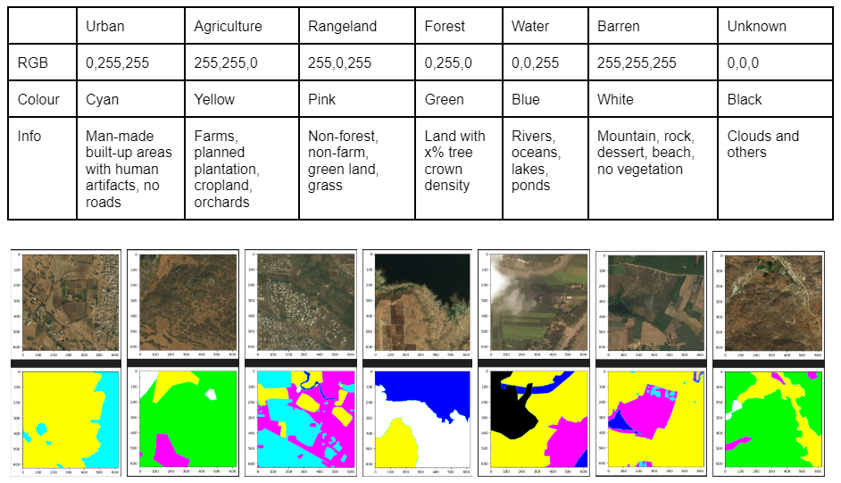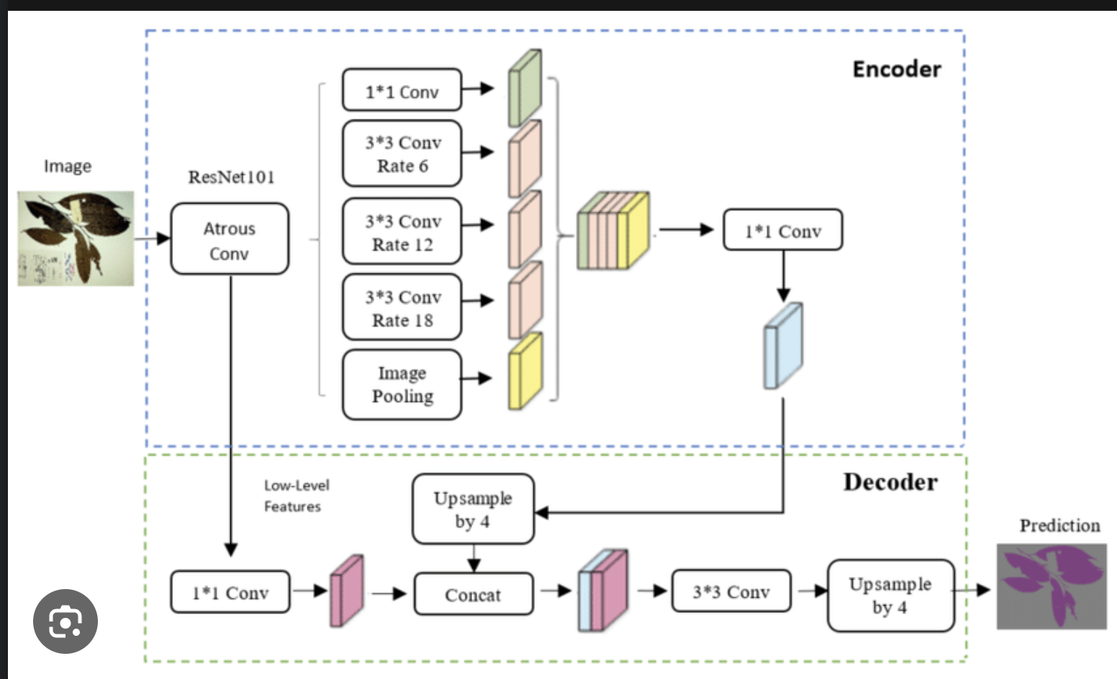

Figure 1: Dataset Details and Samples [5] Figure 2: DeepLab V3+ Network Architecture [6]

While the primary focus is on multi-class segmentation, the project also delves into binary segmentation. The Rangeland class is isolated as the specific output class for binary segmentation. This binary approach aims to enhance precision in identifying areas suitable for seeding.

Scale invariance is a pivotal aspect of the methodology, addressing the challenge of variability in image sizes and heights. The DeepLabV3+ Atrous Spatial Pyramid Pooling architecture[3][7] is leveraged to ensure the model's adaptability to different heights from the ground. Randomly choosing image sizes and locations adds a layer of flexibility, essential for real-world applicability.

The choice of loss functions significantly influences the model's performance. For multi-class segmentation, cross-entropy (CE) is employed, while binary segmentation experiments with binary cross-entropy (BCE), Dice loss, and Focal Tversky Loss. The exploration of loss functions is driven by the need to overcome class imbalances, particularly concerning the Rangeland class, which constitutes only around 10% of the dataset.

The evaluation of the model's performance goes beyond accuracy, incorporating Intersection-Over-Union (IOU), precision, and recall metrics. This comprehensive assessment ensures a nuanced understanding of the model's strengths and areas for improvement.

The project's methodology is characterized by its holistic approach, integrating state-of-the-art architectures, dataset considerations, adaptability to scale variations, and a nuanced exploration of loss functions. This comprehensive methodology sets the stage for advancements in reforestation strategies through the synergy of UAV technology and machine learning methodologies.

**Results:**

The project's multi-class segmentation demonstrates commendable success in categorizing various land cover classes. However, the focal point of improvement lies in accurately segmenting the Rangeland class. The validation mean Intersection over Union (IOU) of approximately 0.3 suggests that enhancements are needed to refine the model's delineation of high-yield seeding areas within this

class. Notably, other classes achieve higher IOU scores ranging from 0.6 to 0.8, underscoring the model's effectiveness in distinguishing urban, agricultural, forest, water, barren, and unknown classes. The intricacies of the Rangeland class, sharing similarities with other land cover types such as barren, agricultural, and forest, pose a unique challenge that warrants focused attention for improvement.

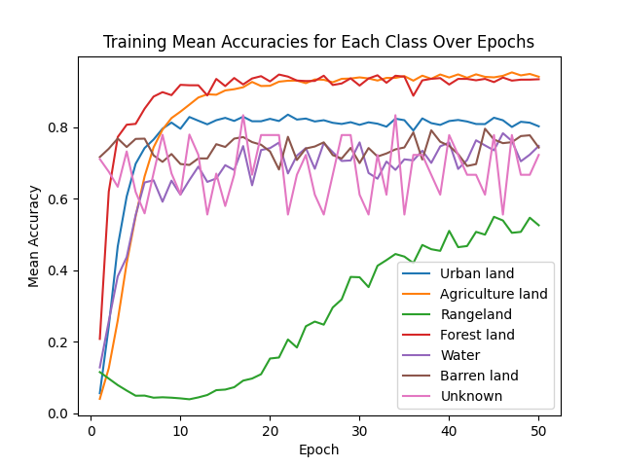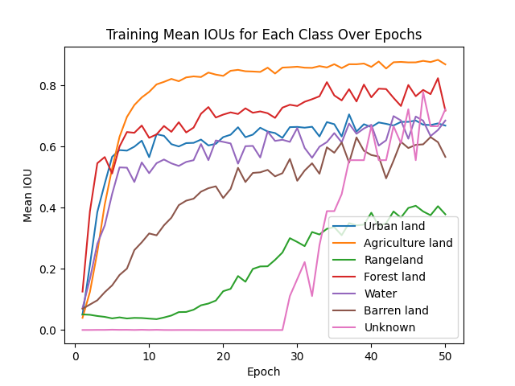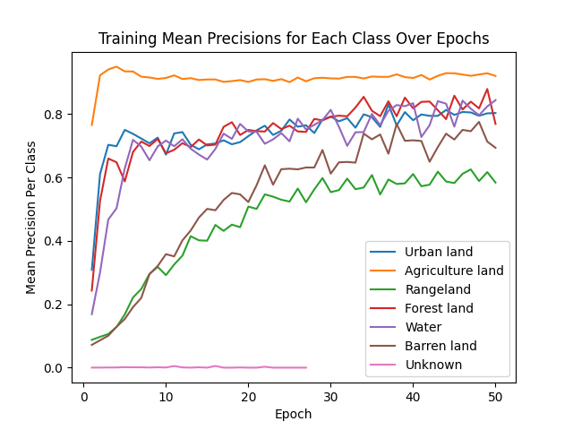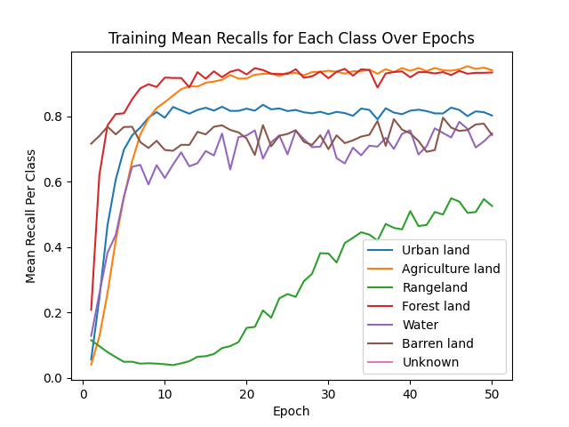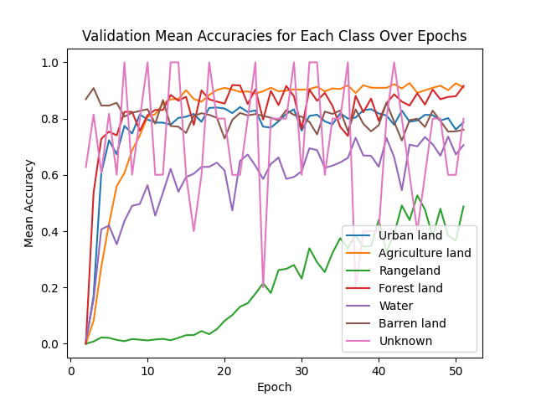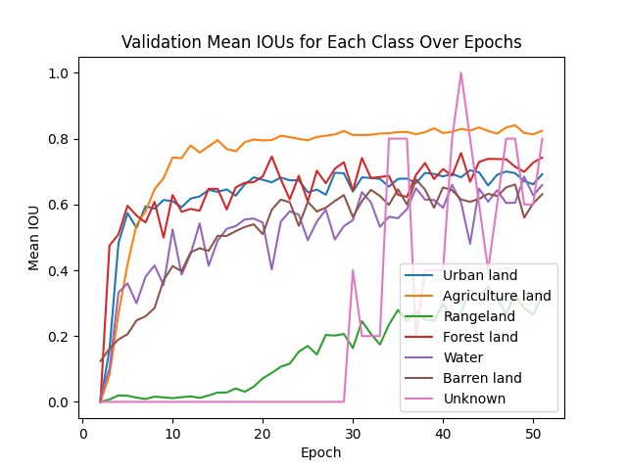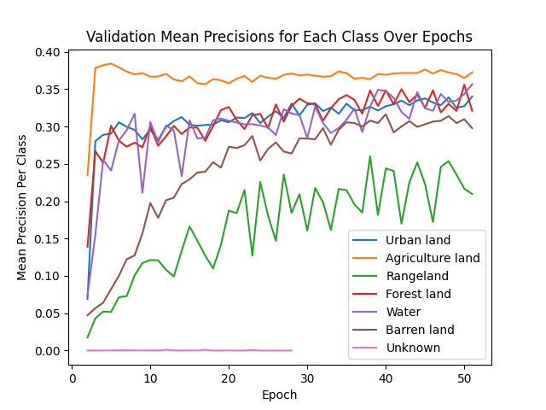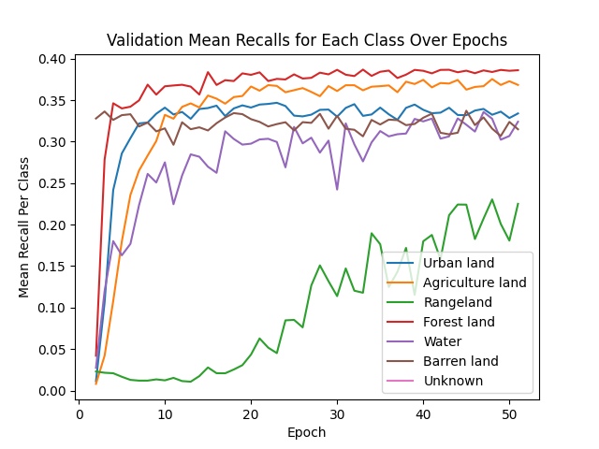

Figure 3: Training and Validation Multi-Class Segmentation Metrics

Figure 4: Multi-Class Segmentation Results. Top: Ground Truth Image, Middle: Ground Truth Segmentation Mask, Bottom: Resulting Segmentation Mask

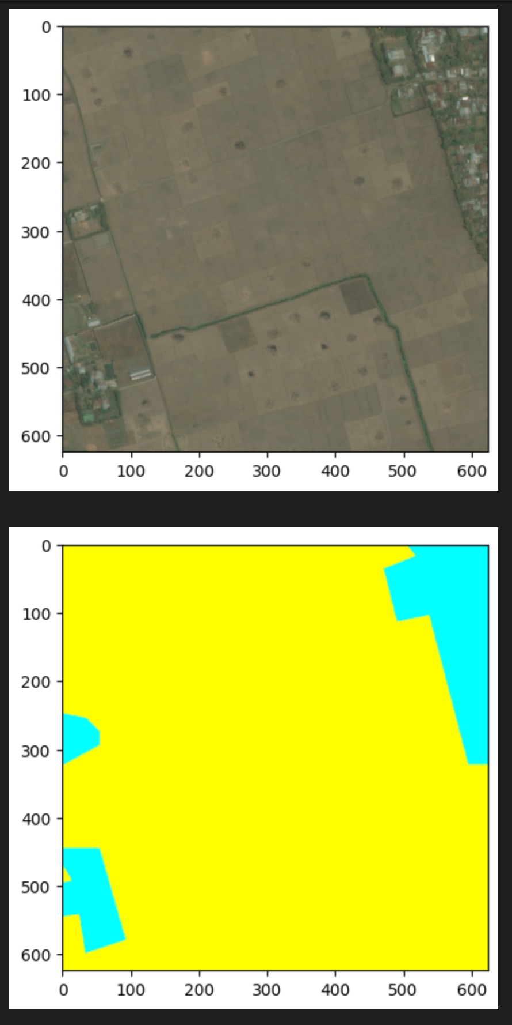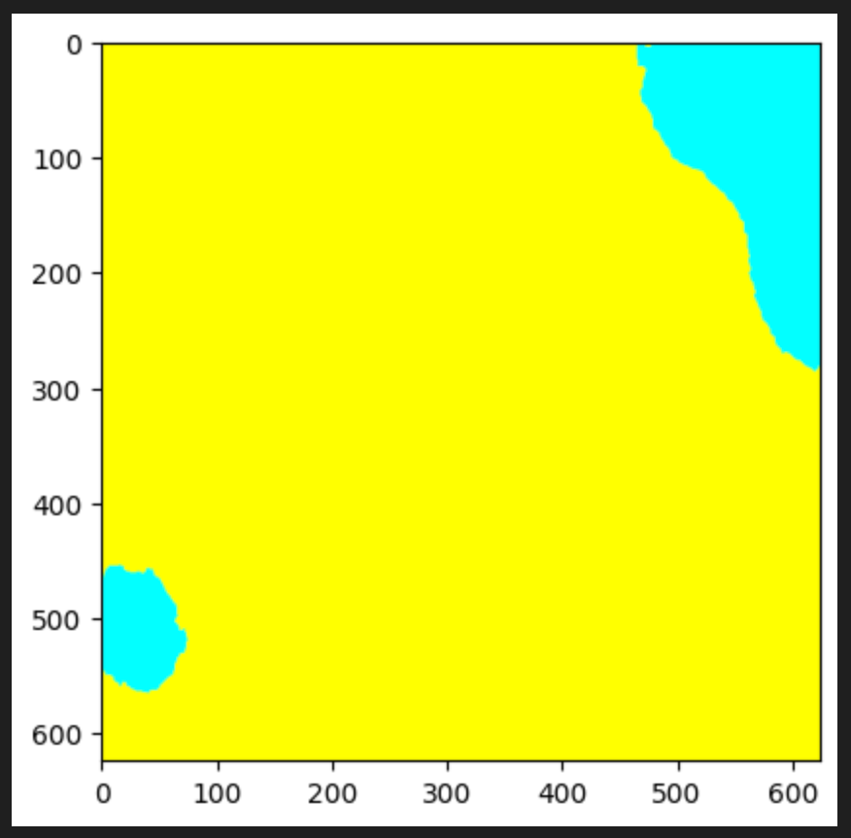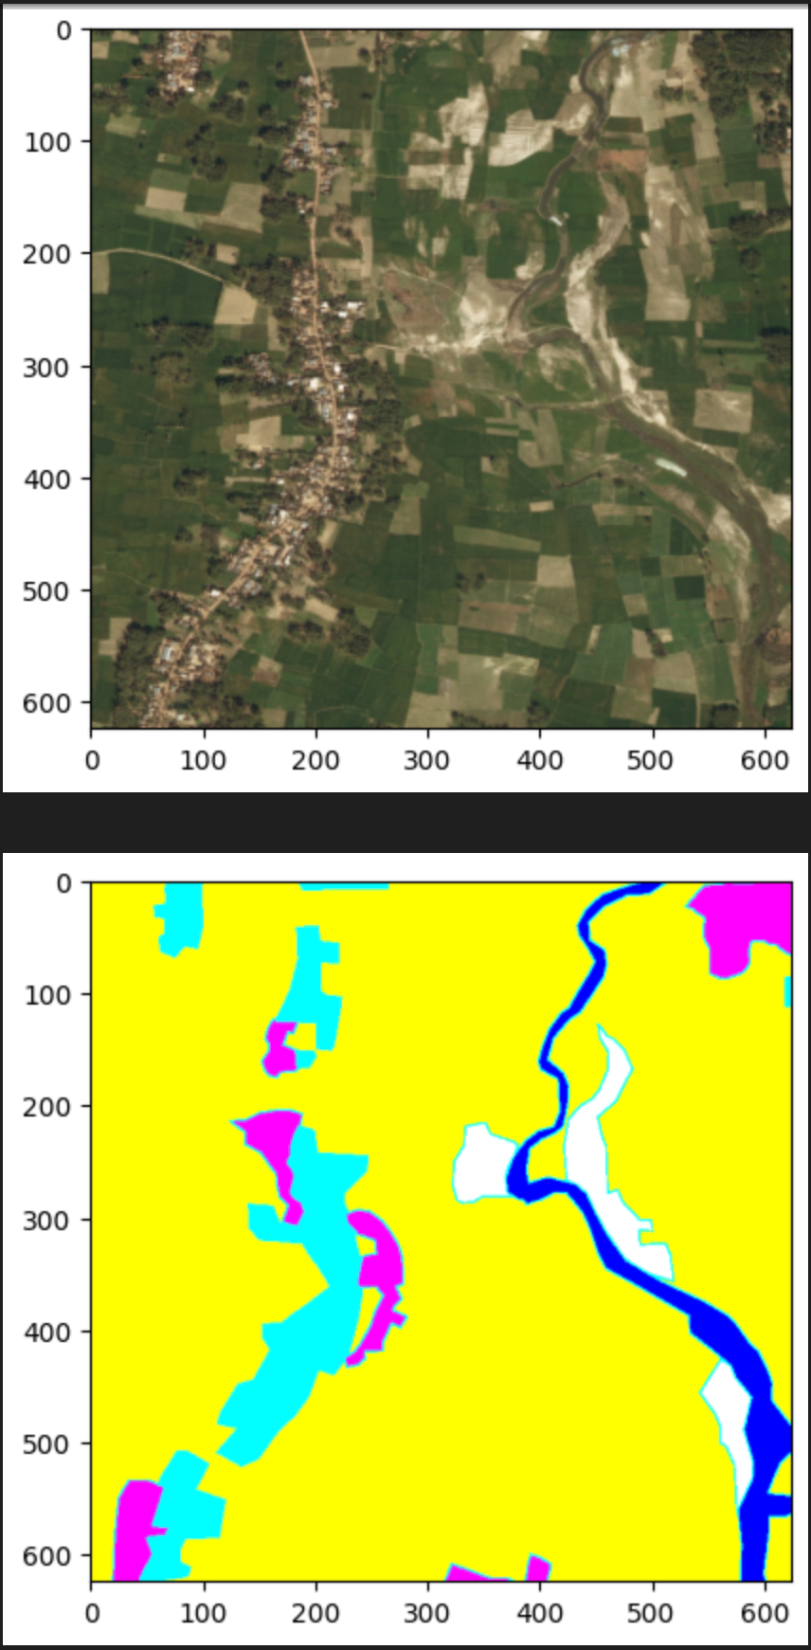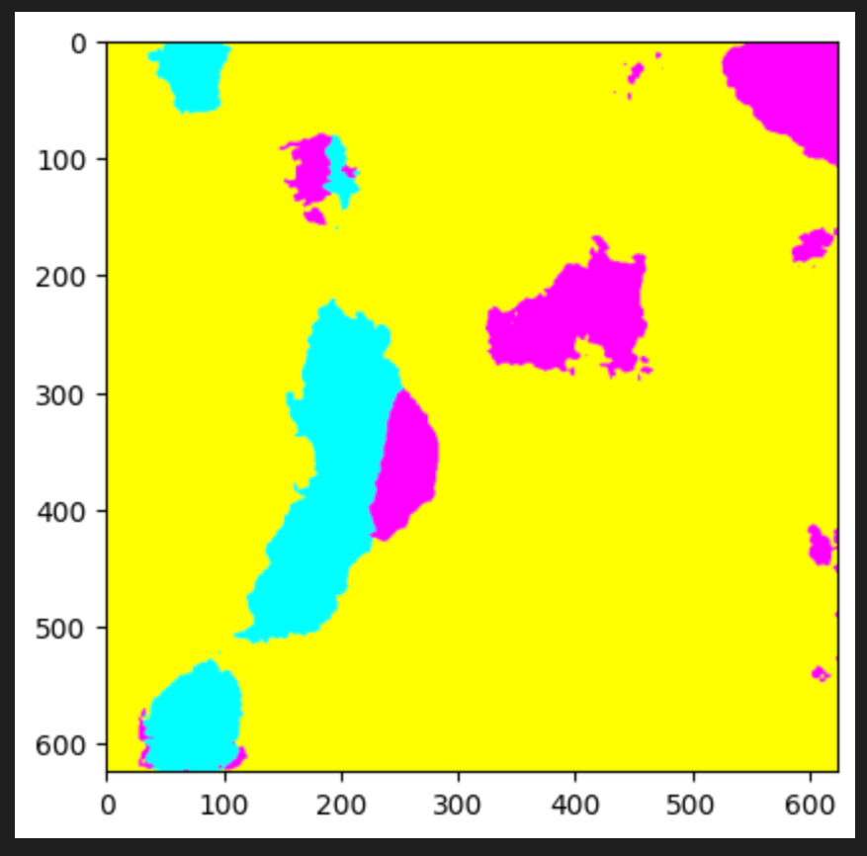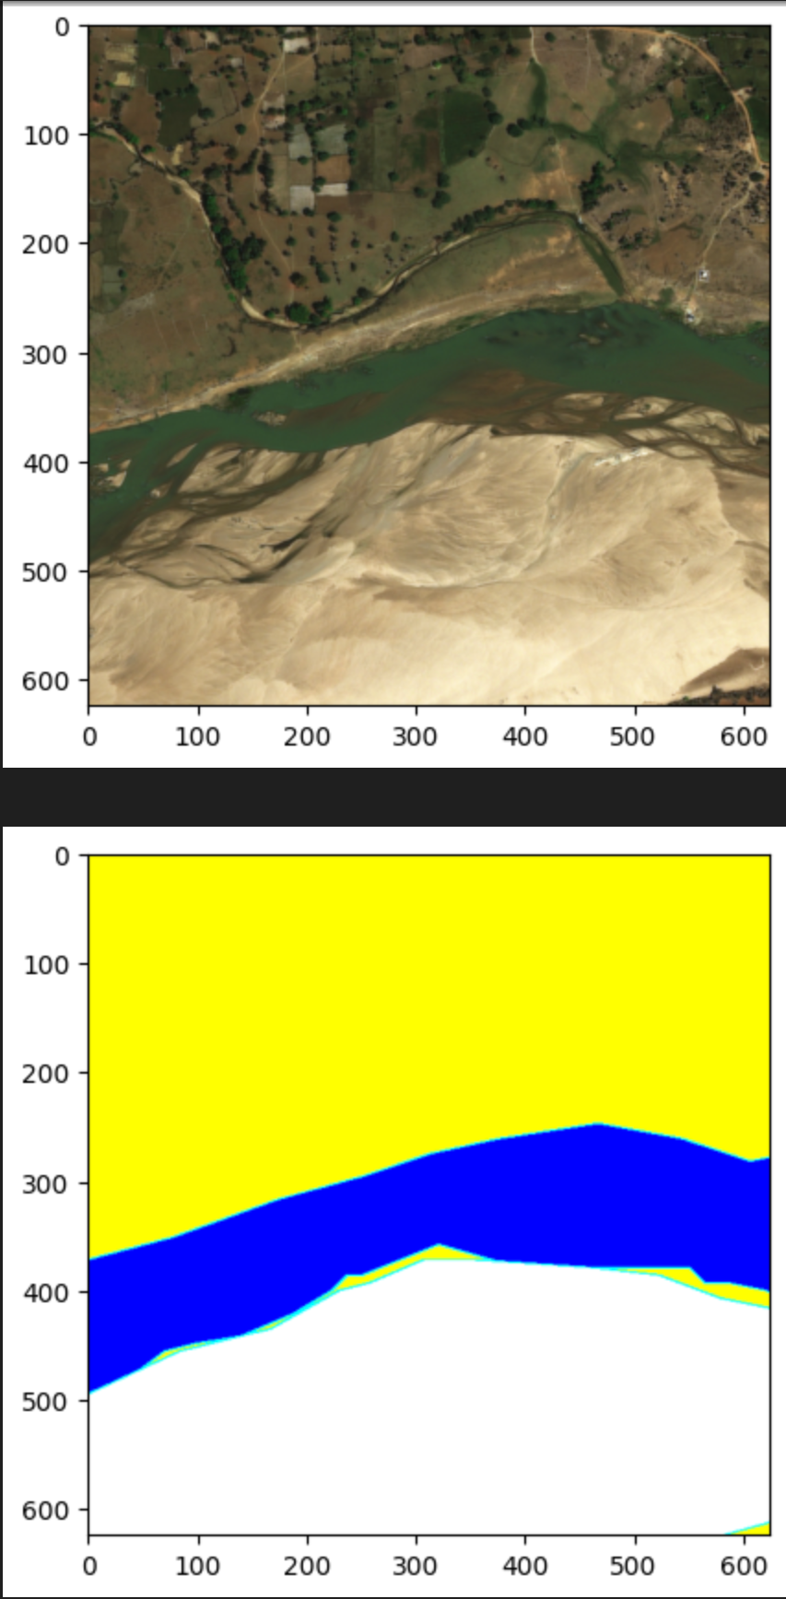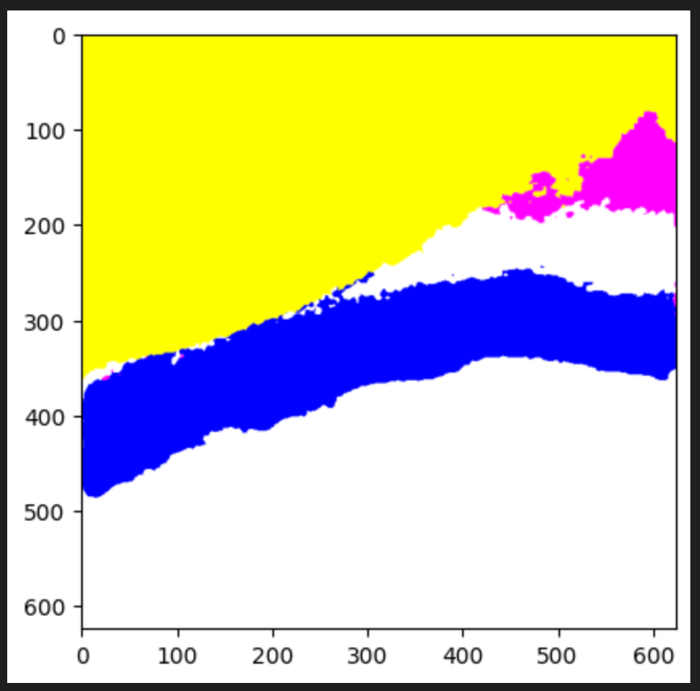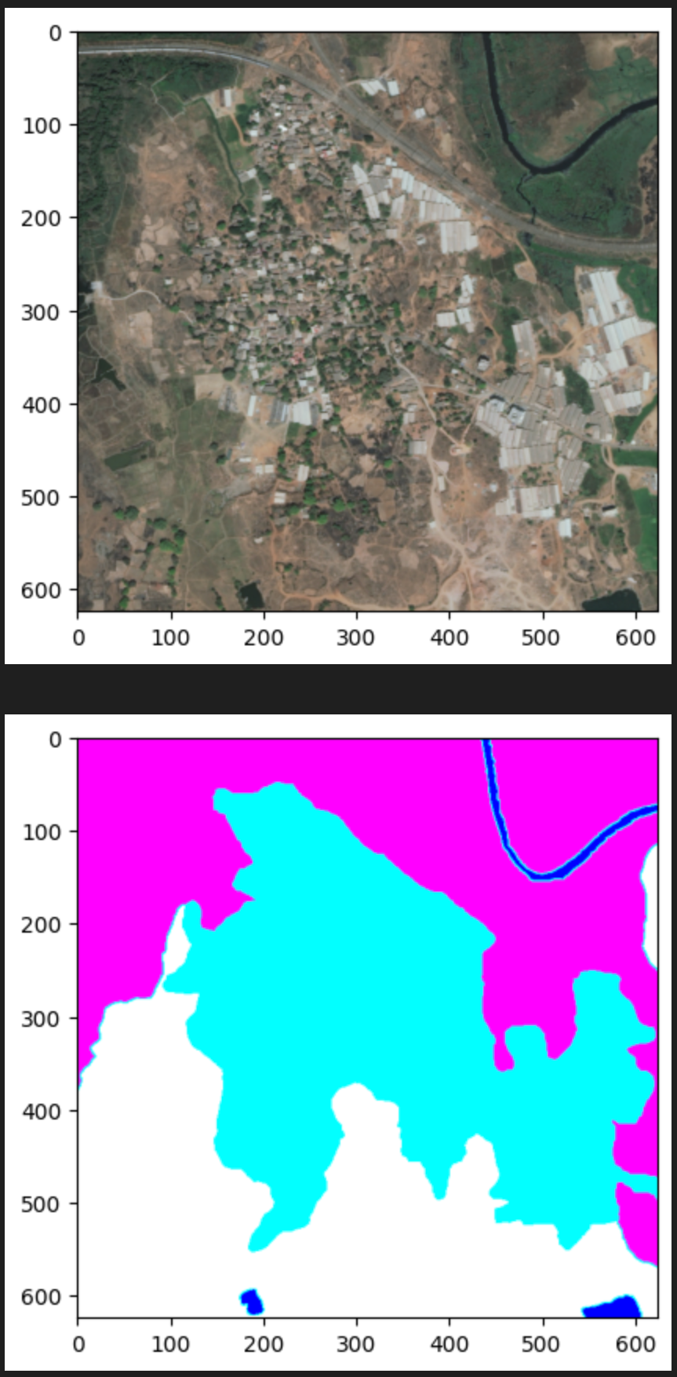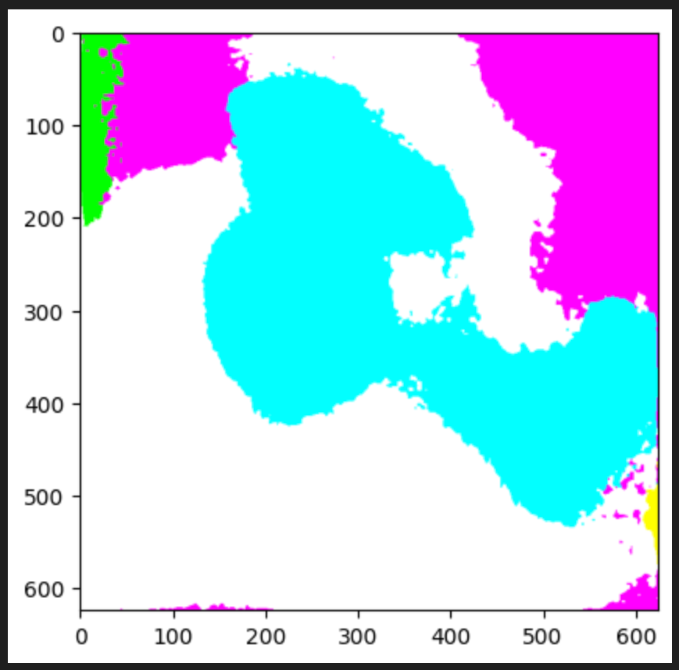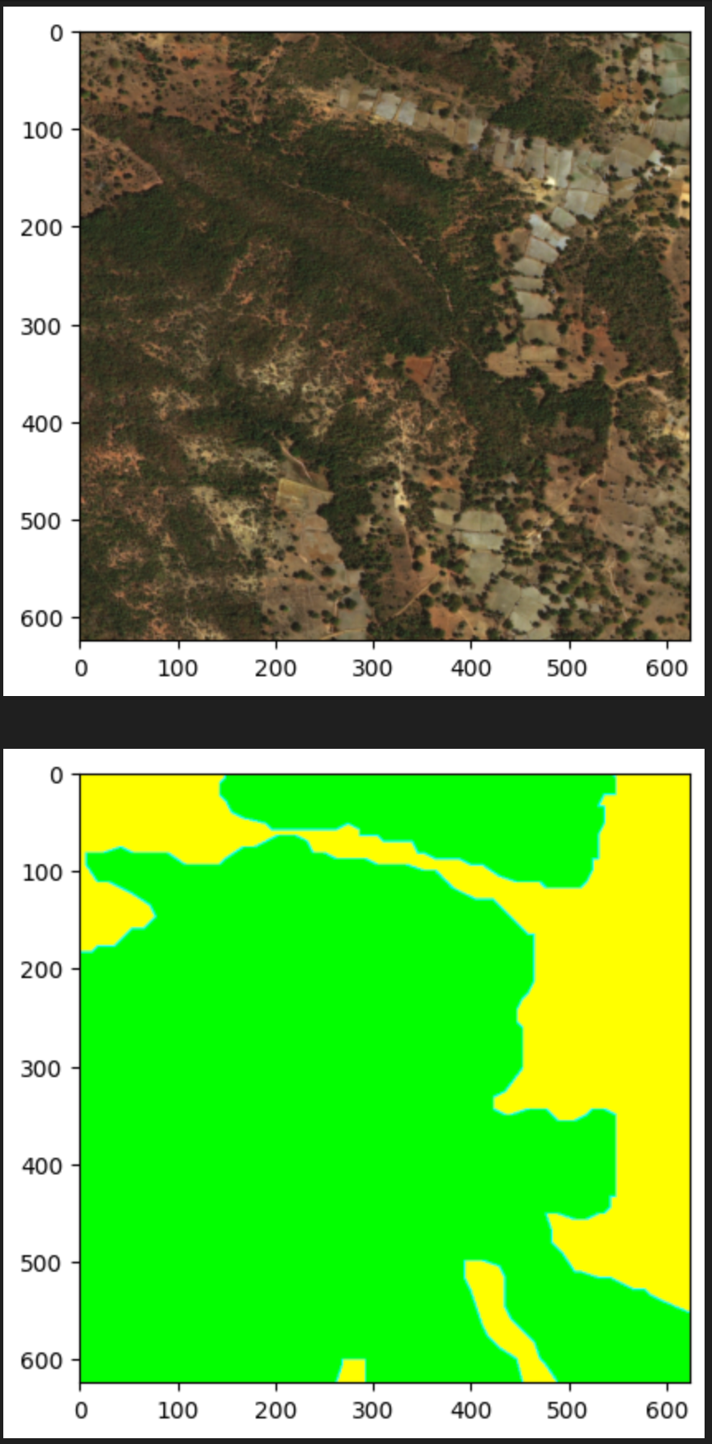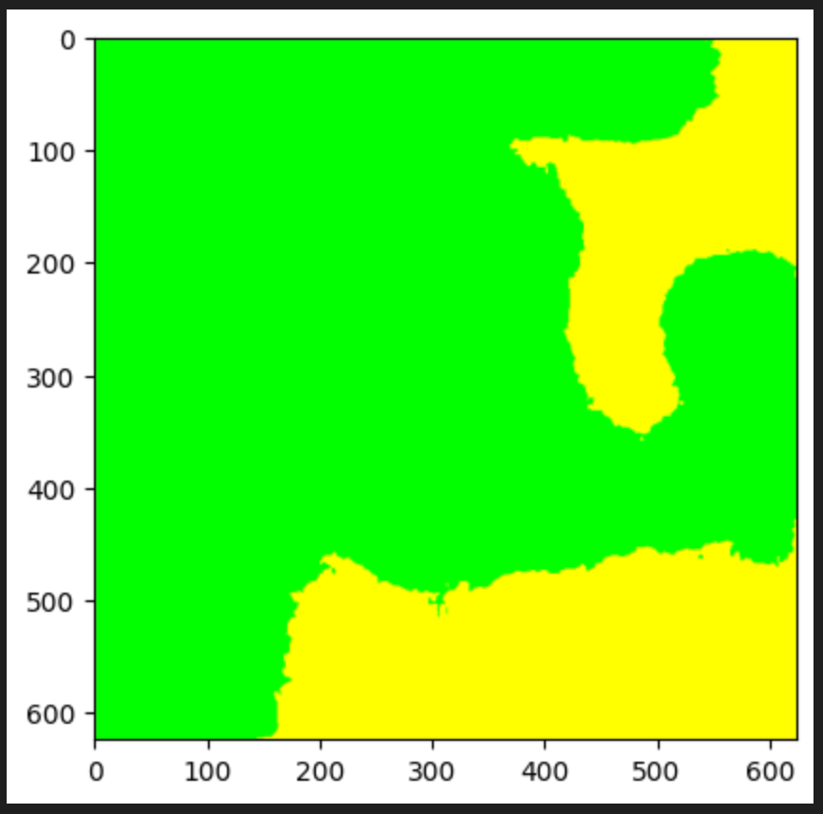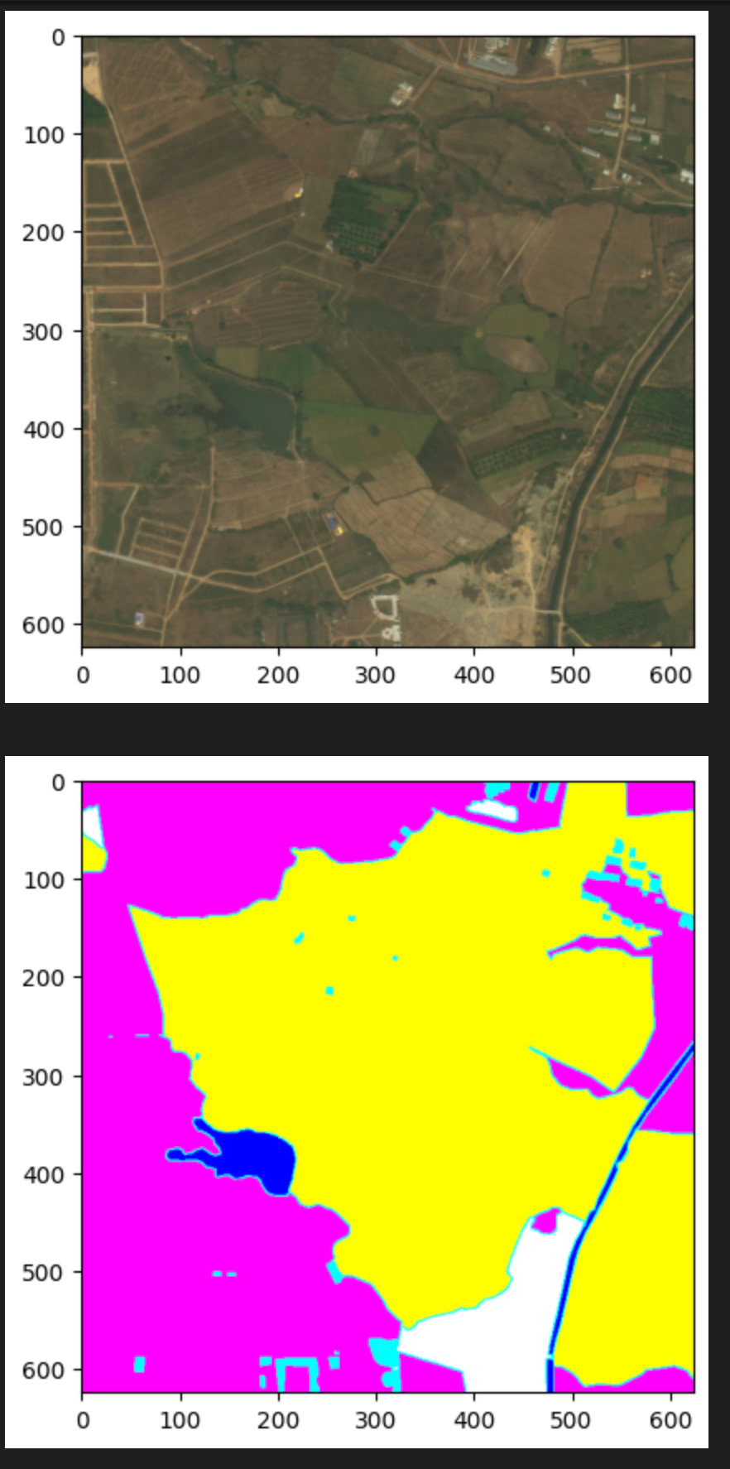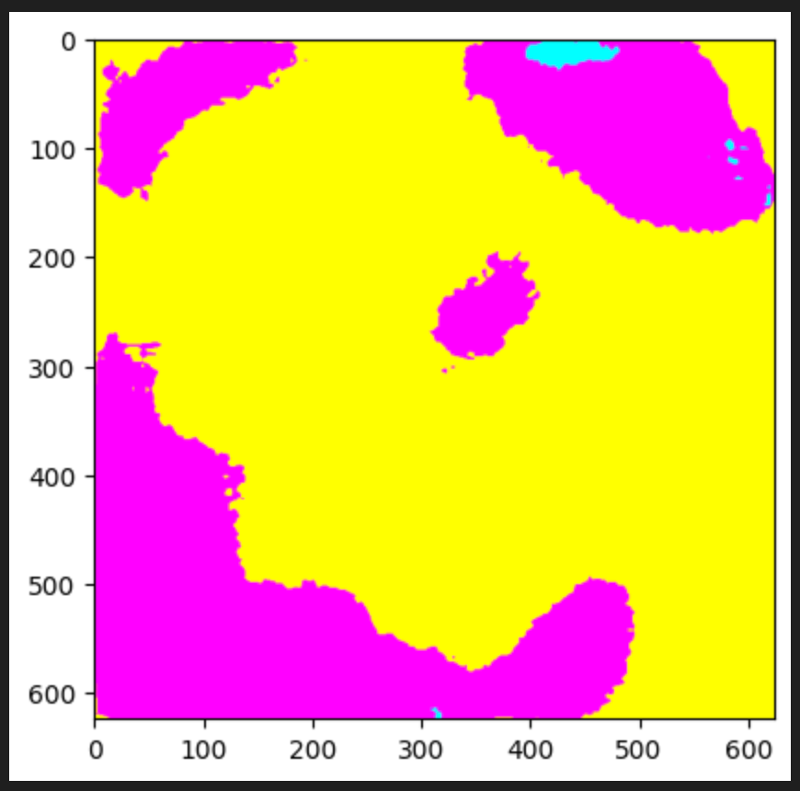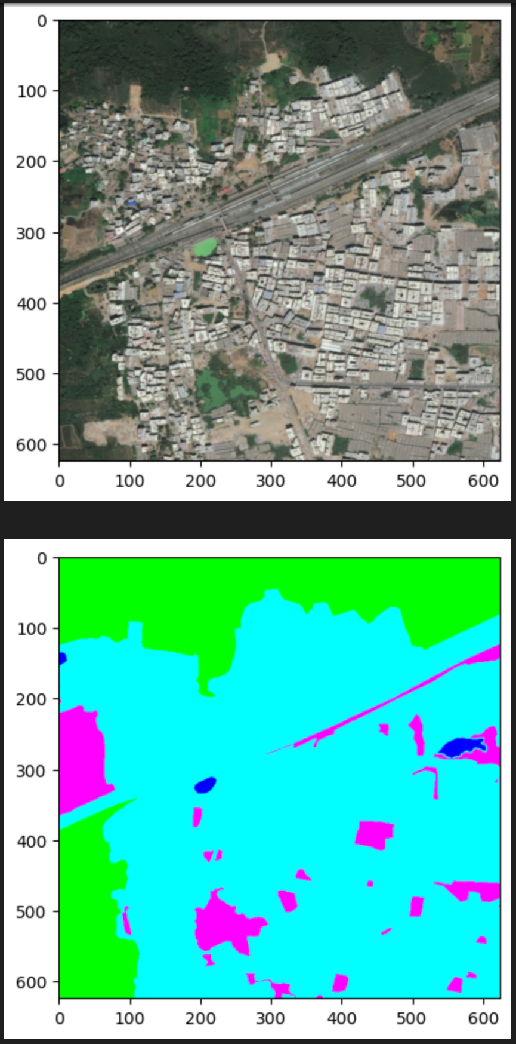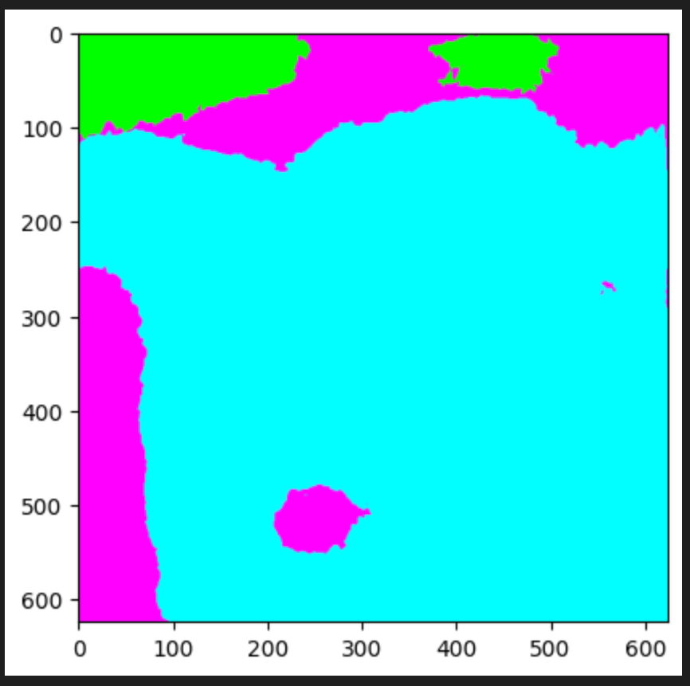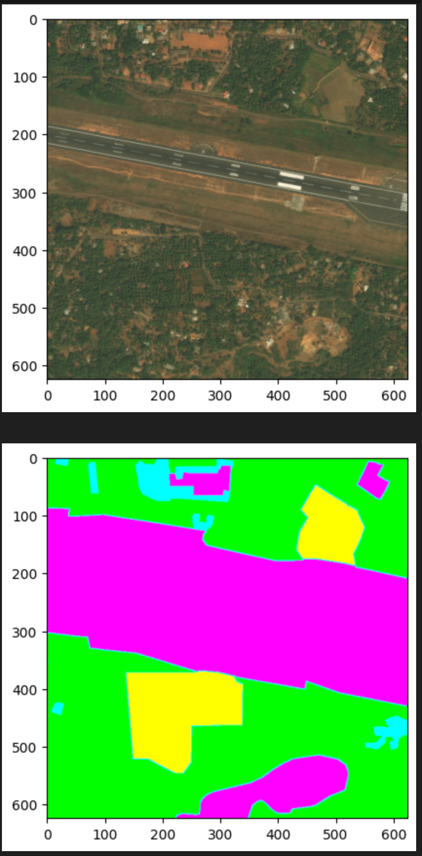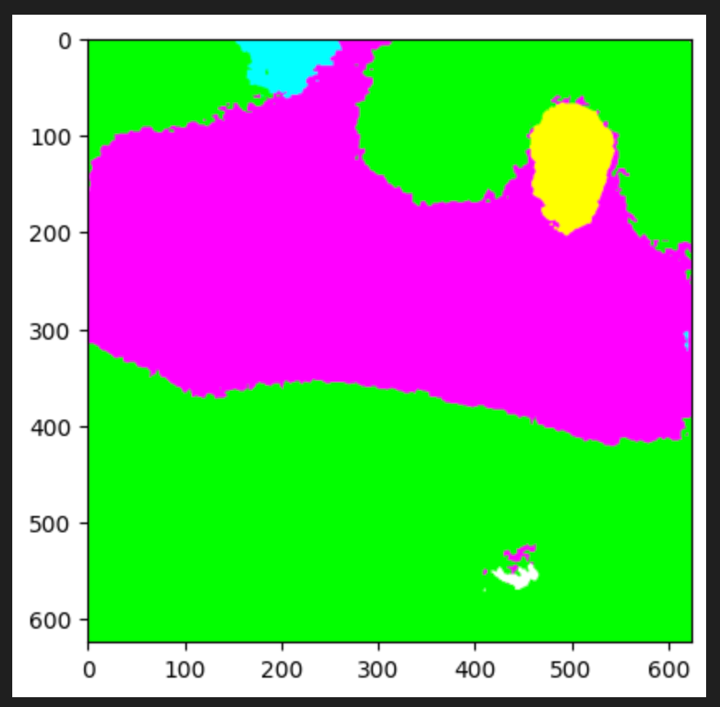

The binary cross entropy segmentation results, concentrating specifically on the Rangeland class, offer valuable insights into the model's capability to pinpoint areas conducive to high-yield seeding. The validation mean IOU for binary segmentation, standing at approximately 0.3, signals a necessity for refinement to enhance the precision of identifying target areas. The validation mean accuracy, peaking at around 0.6, indicates room for improvement in achieving a more precise delineation.

To address intricacies in binary segmentation, the project explores alternative loss functions, incorporating both binary cross-entropy (BCE) and the innovative binary focal Tversky loss. While the results for BCE loss have a high false negative rate, predicting the background class where it is in the target class, binary focal Tversky loss tries to address this shortcoming by weighing false negatives higher in the loss function than false positives. However, no significant improvements in IOU were observed. While these approaches augment the model's capacity to capture more data, persistent challenges in certain regions result in misclassifications and the presence of background elements within target areas. Further exploration and refinement of loss functions are imperative to overcome these challenges and improve the model's accuracy in binary segmentation, especially in identifying high-yield areas within the Rangeland class.

* Multi-class segmentation: the model seems to perform well on many of the classes except for Rangeland class
* Binary segmentation: a similar result occurs for both the BCE and Focal Tversky loss function
* Reason for suboptimal performance is that Rangeland class has a large range and is similar to barren, agricultural and forest classes in cases

Due to the suboptimal performance of binary segmentation on the Rangeland class itself, combining both the forest class and the Rangeland class as the target class was explored. The reason is that the Rangeland class shared similarities with the forest class the most since the Rangeland class often had areas with significant tree density. It is a reasonable assumption because the Forest class is another good class for tree planting but not optimal since there are already trees existing there.

As a result, the validation IOU increased to 0.6 for BCE with the combined target class, but the drawback is that the model now has greater difficulty with identifying grassy areas in the target class.

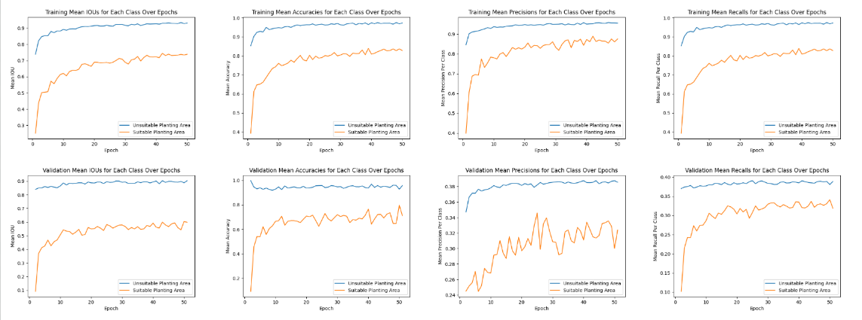

Figure 5: Training and Validation Binary Segmentation Metrics for Combined Target Class using BCE Loss

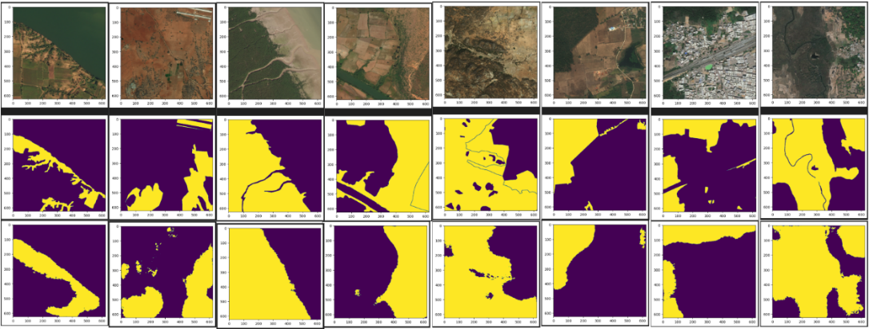

Figure 6: Multi-Class Segmentation Results. Top: Ground Truth Image, Middle: Ground Truth Segmentation Mask, Bottom: Resulting Segmentation Mask (Purple: Background, Yellow: Target)

Figures 7 and 8 give an overview of the tasks performed and important results.

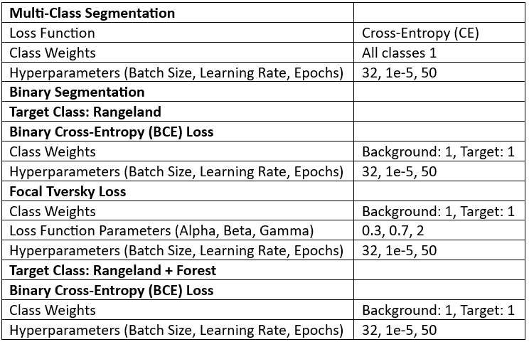 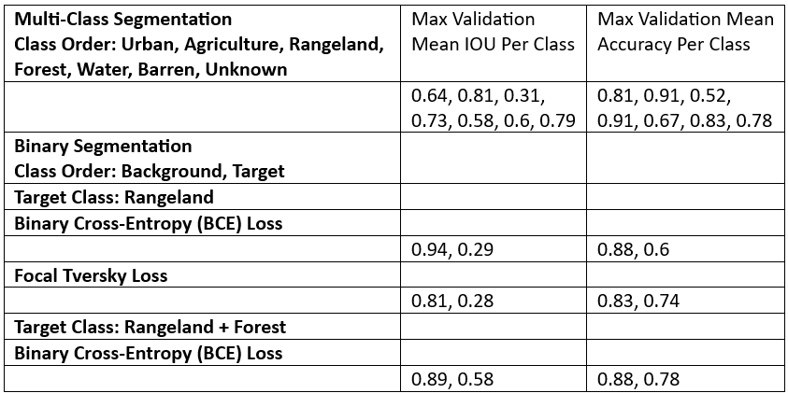Figure 7: Experiments Performed and Corresponding Figure 8: Summary of Significant Results by Class Loss Functions and Parameters Used and Corresponding Class Order

**Discussion:**

The project confronts the intricate task of identifying high-yield areas, particularly within the challenging Rangeland class. The complexity arises from the class's vast range and similarities to other land cover types, demanding a nuanced approach. The quest for effective solutions involves delving into alternative loss functions and refining the model architecture.

Acknowledging the class imbalance issue, especially the underrepresentation of the Rangeland class, the project takes proactive steps. The exploration of class weights in loss functions, along with focal loss and focal Tversky loss, highlights a strategic response to address the imbalance. Future endeavors aim to augment the dataset, introducing more diverse examples to enhance the model's capability to discern the subtleties within the Rangeland class. Future endeavors may also involve creating a stronger separation between classes, which may allow the model to recognize patterns within each class more easily, by replacing the Rangeland class and the Forest class with a Grassland class and a Trees class instead. The task may require a different segmentation dataset.

Amidst these challenges, the project makes significant strides in reforestation strategies. The introduction of scale invariance and innovative modifications to loss functions surpass the standard curriculum, reflecting a dedication to pushing the boundaries of knowledge. The ongoing journey underscores the pivotal role of technology, specifically UAVs and machine learning, in realizing sustainable reforestation and ecosystem restoration goals.

**Future Work**

The project's future work focuses on refining and advancing its reforestation model. Key initiatives include addressing class imbalance through the introduction of class weights, exploring alternative loss functions like focal loss to enhance the model's ability to distinguish land cover types, and expanding the dataset for improved generalization. Testing the model on additional datasets ensures its versatility, while investigating the impact of scale invariance aims to optimize real-world applicability. The project's holistic approach aligns with its commitment to evolving reforestation strategies, emphasizing the integration of UAVs and machine learning for sustainable ecological restoration efforts.

**Conclusion**

The conclusion underscores the project's groundbreaking fusion of UAV technology and advanced machine learning for reforestation. Although proficient in multi-class segmentation, challenges remain in identifying high-yield areas in binary segmentation. Notably, the project surpasses standard course material, incorporating innovations like scale invariance and exploring modifications to loss functions, making a valuable contribution to ecological restoration. The timeline reflects a commitment to academic rigor, meeting course requirements. The ongoing journey is dedicated to tackling complexities, emphasizing the use of technology for sustainable reforestation and ecosystem restoration, showcasing a forward-looking perspective in environmental conservation.

**Acknowledgement:**

References:

[1] C. Asher, “New Tree Tech: Cutting-Edge drones give reforestation a helping hand”, Mongobay, 2023.

[2] V. Hodgem R. Hawkins, R. Alexander, “Deep Reinforcement Learning for drone navigation using sensor data”, Springer, 2020. <https://link.springer.com/article/10.1007/s00521-020-05097-x>. Last accessed: October 2023.

[3] Chen, L.-C., Zhu, Y., Papandreou, G., Schroff, F., & Adam, H. (2018, August 22). *Encoder-decoder with atrous separable convolution for Semantic Image segmentation*. arXiv.org. <https://arxiv.org/abs/1802.02611>

[4] Conca, J. (2020, September 30). *Drones can reforest the planet faster than humans can*. Forbes. https://www.forbes.com/sites/jamesconca/2020/09/30/drones-can-reforest-the-planet-faster-than-humans-can/?sh=3e075964341f

[5] B. Ashwath, “DeepGlobe Land Cover Classification Dataset”, Kaggle, 2020. <https://www.kaggle.com/datasets/balraj98/deepglobe-land-cover-classification-dataset/data>. Last accessed: October 2023

[6] Hussein, B. R., Malik, O. A., Ong, W.-H., & Slik, J. W. F. (1970, January 1). *Semantic segmentation of herbarium specimens using Deep Learning Techniques*. SpringerLink. https://link.springer.com/chapter/10.1007/978-981-15-0058-9_31

[7] Fezan. (2020, June 29). *Review Deeplabv3 (semantic segmentation)*. Medium. https://medium.com/swlh/review-deeplabv3-semantic-segmentation-52c00ddbf28d

[8] S. Waslander, AER1515 Course lectures, Fall 2023, University of Toronto.

[9] S. Jadon, (2020, September 3). *A survey of loss functions for semantic segmentation*. arXiv.org. <https://arxiv.org/abs/2006.14822>